

Ceva accelerates its Companion Animals ambition with a strategic focus on the United States

Ceva Animal Health appoints Laura Correro as Senior Vice President for Companion Animals franchise and relocates Executive Vice President Jean-Marcel Ciet to the United States to spearhead the group's strategic push in one of the world's most dynamic pet healthcare markets.

 | 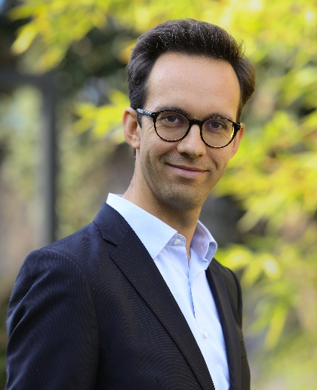
Laura Correro  Senior Vice President  Companion Animals franchise | Jean-Marcel Ciet  Executive Vice President  Global Companion Animals

Libourne, June 22th, 2026 – The companion animals segment is no longer a growth opportunity for Ceva, it is a strategic priority. To match ambition with action, Ceva Animal Health, the world’s fifth largest animal health company, today announces two decisive moves: the appointment of Laura Correro as Senior Vice President for Companion Animals franchise, and the relocation of Jean-Marcel Ciet, Executive Vice President for Global Companion Animals and a member of Ceva's Executive Committee, to Bridgewater, New Jersey; the operational base of Ceva's commercial subsidiary in the United States.
Together, these appointments signal a clear commitment: Ceva is investing in the talent, the structure, and the geographic presence required to compete at the highest level in the companion animals market.
A seasoned global executive to lead the Companion Animals franchise
Laura Correro brings over 20 years of international experience in global marketing, sales, and P&L management across the animal health and consumer health industries. Most recently, as Head of Franchises Pet Therapeutics at Boehringer Ingelheim Animal Health, she led global strategic marketing across veterinary channels, driving priority innovations and long-term pipeline development. Prior to that, she spent 12 years at Procter & Gamble, where she built deep expertise in iconic global brand management and over-the-counter (OTC) pharmaceutical sector.
In her new role, Laura Correro will be responsible for defining, steering, and implementing the global strategy for Ceva's pet care segment. She will drive growth across the veterinary channel and accelerate the development of a multichannel product portfolio, with a particular focus on strengthening Ceva's presence in key international markets.
Laura Correro comments: "I am very pleased to join Ceva at this important juncture in its development. The Companion Animals business has strong assets and excellent growth prospects. In a rapidly evolving environment, I am convinced that innovation and close collaboration with animal care stakeholders will be essential to meeting market expectations. I look forward to contributing to this ambition alongside the Ceva teams."

Jean-Marcel Ciet relocates to the United States to drive strategic acceleration
To reinforce Ceva's ambition for the U.S. market, Jean-Marcel Ciet, Executive Vice President for Global Companion Animals and a member of Ceva's Executive Committee, will relocate to Bridgewater, New Jersey. From this base, he will directly oversee the acceleration of Ceva's companion animals strategy in the United States, working in close coordination with local teams and supporting the group's broader ambitions in this critical market.
The United States represents the largest and most influential pet care market globally, within a North American region that alone accounts for over 40% of global market value. With its scale, innovation capacity, and highly developed veterinary ecosystem, it concentrates a significant share of industry momentum and sets the pace for many global trends. Establishing senior leadership locally will enable Ceva to stay close to market dynamics, strengthen execution, and better connect with customers and partners on the ground.

Jean-Marcel Ciet comments: "Laura's appointment is a major step forward for our franchise. She brings a strong combination of strategic and commercial experience that will help us continue to build our companion animals business over time.
The U.S. is the world's leading pet care market, and our decision to anchor senior leadership on the ground there reflects how seriously we take this opportunity. I am genuinely excited to work alongside Laura and our U.S. teams to build something meaningful here."

A strategic reorientation backed at the highest level
This dual announcement reflects a broader strategic focus that has the full support of Ceva's senior leadership.
Sébastien Huron, Deputy CEO of Ceva Animal Health, comments: " The companion animals segment is a key area of development for Ceva, and the United States plays a central role in this landscape. With these decisions, we are strengthening both our leadership and our presence in a market that is highly competitive and fast-moving. Bringing Laura on board and positioning Jean-Marcel in the U.S. reflects our intention to build our capabilities over time, step by step, to better serve our customers.

-- END –

About Ceva Animal Health

Ceva Animal Health (Ceva) is the 5th global largest animal health company, led by experienced veterinarians, whose mission is to provide innovative health solutions for all animals to ensure the highest level of care and well-being. Our portfolio includes preventive medicine such as vaccines and animal welfare products, pharmaceutical solutions for farm and companion animals, as well as equipment and services to provide the best experience for our customers.

With more than 7,200 employees located in 47 countries, Ceva strives daily to bring to life its vision as a One Health company: “Together, beyond animal health”.

2025 turnover: €1.92 billion

www.ceva.com

Pet Care Market (2026 - 2033) – Grand View Research

